Full name: Adeyemo Adetoye
Registration number: C11/26/FCDF/17140
Linux distribution / version: Version 7.2.10r174163
VM hostname: Kali

2.2 Practical conversion exercises with step by step workings

Convert 101010₂ to decimal
Solution
Multiply each binary digit by its corresponding power of 2, starting from the right with $2^{0}$.
$${101010}_{2}$$
Binary digit | Power of 2 | Calculation
0 | $2^{0}$​ | 0 × 1 = 0
1 | $2^{1}$​ | 1 × 2 = 2
0 | $2^{2}$​ | 0 × 4 = 0
1 | $2^{3}$​ | 1 × 8 = 8
0 | $2^{4}$​ | 0 × 16 = 0
1 | $2^{5}$​ | 1 × 32 = 32
Add the results:
$$32+8+2=42$$
Final answer
$$\boxed{{101010}_{2}={42}_{10}}$$

Exercise 2: Convert AB2₁₆ to decimal
Solution
In hexadecimal:
A = 10, B = 11, 2 = 2
Multiply each digit by its corresponding power of 16.
$$AB2_{16}$$
$$=(10×{16}^{2})+(11×{16}^{1})+(2×{16}^{0})$$
=(10×256)+(11×16)+(2×1)
=2560+176+2
=2738
Final answer
$$\boxed{AB2_{16}={2738}_{10}}$$

Exercise 3: Convert 126₁₀ to binary
Solution
Divide the decimal number by 2 repeatedly and record the remainders.
Division | Quotient | Remainder
126 ÷ 2 | 63 | 0
63 ÷ 2 | 31 | 1
31 ÷ 2 | 15 | 1
15 ÷ 2 | 7 | 1
7 ÷ 2 | 3 | 1
3 ÷ 2 | 1 | 1
1 ÷ 2 | 0 | 1
Read the remainders from bottom to top.
$$1111110$$
Final answer
$$\boxed{{126}_{10}={1111110}_{2}}$$

Exercise 4: Convert 2738₁₀ to hexadecimal
Solution
Divide the decimal number by 16 repeatedly.
Division | Quotient | Remainder
2738 ÷ 16 | 171 | 2
171 ÷ 16 | 10 | 11 (B)
10 ÷ 16 | 0 | 10 (A)
Read the remainders from bottom to top.
$$A, B, 2$$
Remember that 10 = A and 11 = B in hexadecimal.
Final answer
$$\boxed{{2738}_{10}=AB2_{16}}$$

Exercise 5: Convert 101010110010₂ to hexadecimal
Solution
Group the binary digits into sets of four, starting from the right.
$$1010 1011 0010$$
Convert each group into its hexadecimal equivalent.
Binary group | Decimal equivalent | Hexadecimal
1010 | 10 | A
1011 | 11 | B
0010 | 2 | 2
Combine the hexadecimal digits.
$$AB2$$
Final answer
$$\boxed{{101010110010}_{2}=AB2_{16}}$$

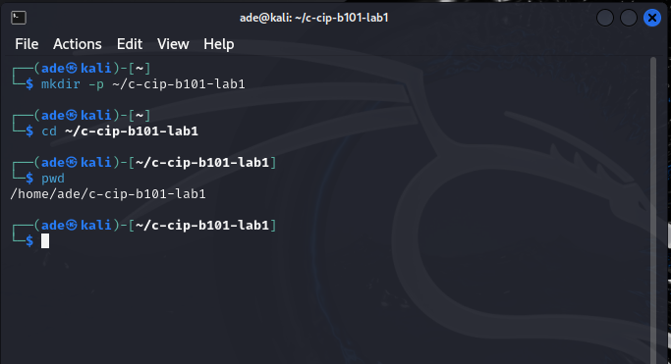

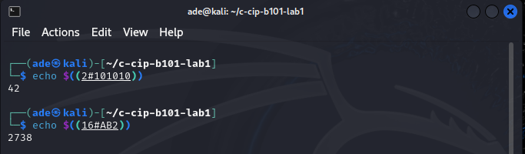
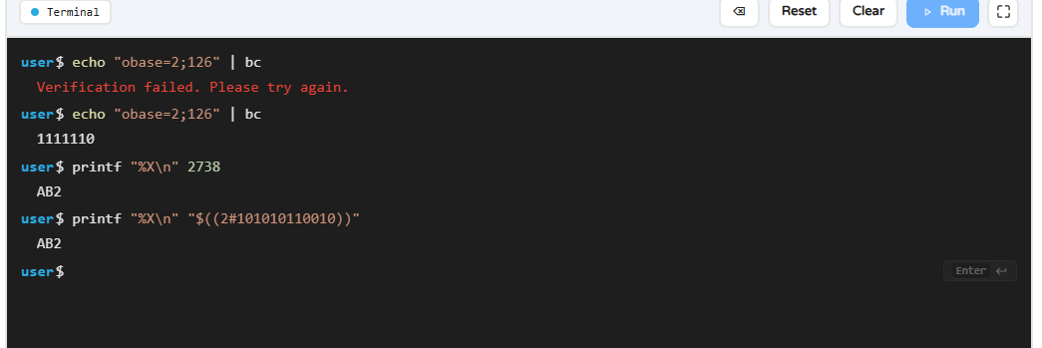

3. Task B - ASCII, UTF-8 and Hex Evidence Strings
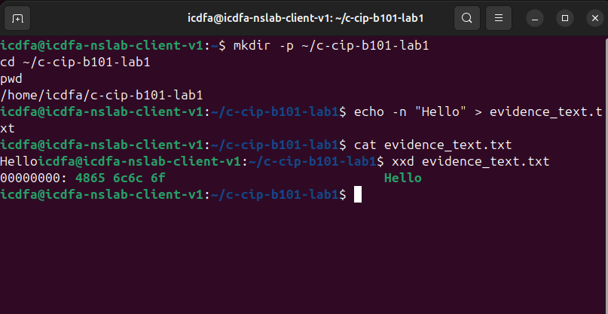
Hexadecimal | ASCII character
48 | H
65 | e
6c | l
6c | l
6f | o

Therefore: 48656c6c6f₁₆ = Hello
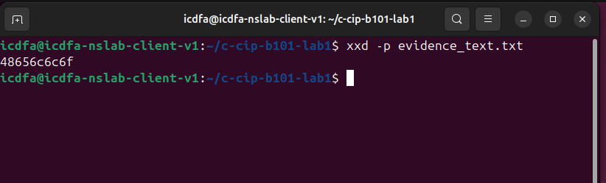
Method 1: Using printf
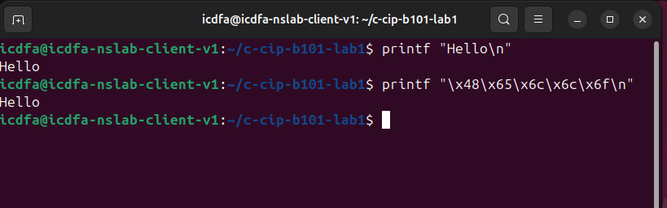
Python conversion
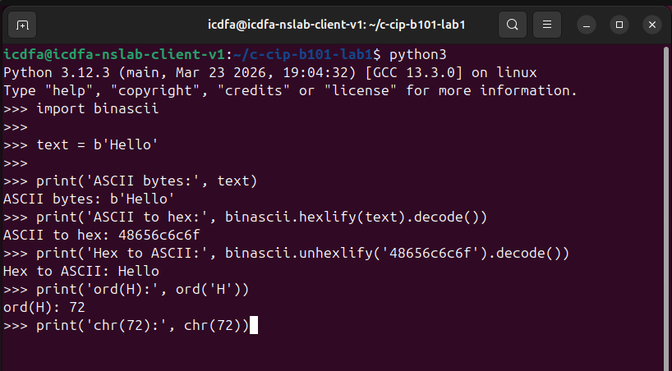

Student exercises
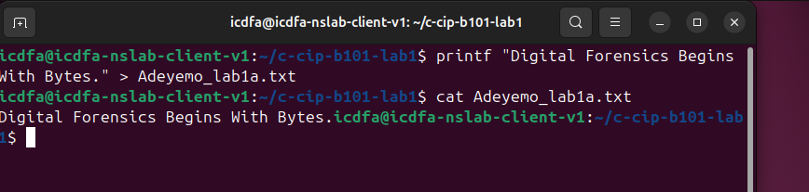

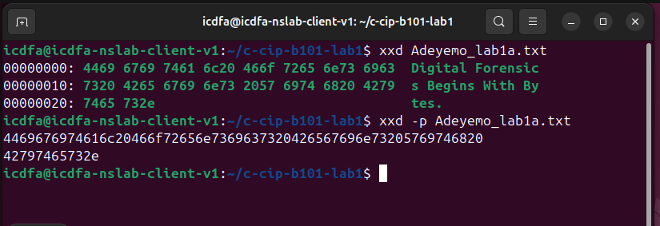

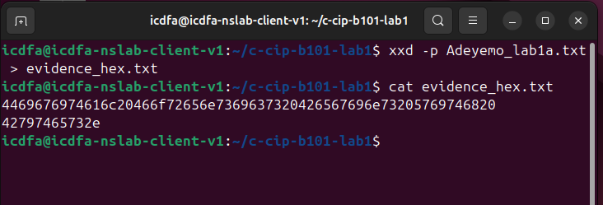

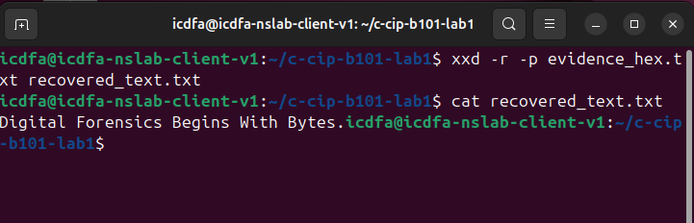
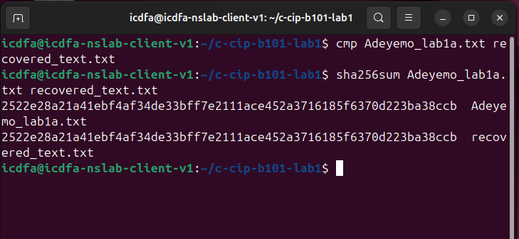

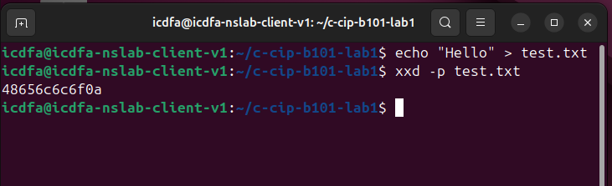
What does 0A mean?
0A is the hexadecimal representation of the Line Feed (LF) character. It represents a newline in Unix and Linux systems.
Why should a forensic examiner not assume every hexadecimal value represents readable text?
Hexadecimal values represent individual bytes. Although some bytes correspond to readable ASCII or UTF 8 characters, others may represent binary structures, executable instructions, compressed files, images or encrypted information. Therefore, forensic investigators must examine the context and encoding of the evidence before interpreting hexadecimal values as text. Misinterpreting binary data as readable text could lead to incorrect conclusions during an investigation.

4. Task C - Epoch Time and Forensic Timestamps


